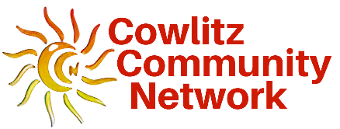
Cowlitz Community Network
360-442-7089 | 207 N. 4th Avenue, Kelso, WA 98626
CowlitzCommunityNetwork.com | CowlitzNtwk@CowlitzCommunityNetwork.com

BOARD MEMBER APPLICATION

Cowlitz Community Network brings the community together and creates
opportunities to help at-risk youth and families succeed.

Thank you for your interest in serving on the Cowlitz Community Network (CCN) Board and making a positive difference for local at-risk youth and families. Board members share responsibility for establishing goals and priorities, making decisions regarding programs and services, identifying funding, determining the use of resources, and objectively measuring CCN’s performance.

In 1992, the state of Washington passed RCW.190 into law, authorizing the creation of the Family Policy Council and over 40 community networks to help mitigate and reduce adverse childhood experiences (ACEs). CCN is one of the few remaining networks in the state.

The CCN Board meets on the third Tuesday of each month from 11:30am-1:00pm. Meetings are held in person at the Cowlitz County Administrative Building Annex, 2nd Floor Conference Room, at 207 N. 4th Avenue in Kelso, WA and by conference call or virtual meeting. Board meetings are subject to the Open Public Meetings Act.

Please complete and return the application to CowlitzNtwk@CowlitzCommunityNetwork.com.

Name |  | Date
Email |  | Phone
Street Address
City, State, Zip |  | County
Organization, Agency or Community Served
Declaration of Fiduciary Interest  (check all that apply) | I do not have fiduciary interest in the health, educational, social service, or justice system.  I do have a fiduciary interest in the health, educational, social service, or justice system because:  I am an employee, manager, paid board member or recipient  of service contracts from a health, educational, social service, or justice  system organization that receives public funds  I have budgetary or policy-making authority for a health, educational,  social service or justice system organization that receives public funds.

1 | Why are you interested in serving on the CCN Board?
2 | Please describe strengths, skills, and expertise you would bring to the Board:
3 | What do you believe are the most significant issues facing youth and families in Cowlitz County?
4 | Please list any memberships in community, professional and/or civic organizations (include elected/appointed offices)

